**AR & VR**

**TEAM- VISUALIZERS**

**Name:- Parthib Ranjan Ray**

**Registration Number:- RA1911003010664**

**Github Link:-**https://github.com/parthibray2002/Augmented-and-Virtual-Reality

**ABOUT**

In this report we will be working to integrate blender animation with an AI based model using python which makes the animation's face to mimic the movements of your face.

**PREREQUISITES**

Inorder to implement we need following Softwares & Scripts:

1. Blender Version 2.8
2. Animation Character file
3. AI Model

**IMPLEMENTATION**

**Step 1 :** After Downloading above mentioned Softwares & Scripts then open the Vincent Animation character file.

**Step 2 :** Search for command prompt in the task bar and click “Run as administrator” .And enter following commands.

* **D:\Semester-6\ARVR\Lab\2.82\python\bin**  (Changing directory to install OpenCV module)
* **python -m pip install –upgrade pip**  (Upgrading python modules)
* **Python -m pip install opencv-contrib-python numpy** (Installing opencv library)

In Order to run the AI Model python script in the blender we have installed the opencv module in python.

**Step 3 :** Clone the repo in order to run the AI model from [**https://github.com/ProtoHubs-io/Blender_FaceMesh.git**](https://github.com/ProtoHubs-io/Blender_FaceMesh.git)

**Step 4 :** In the Animation file on Blender go to **Scripting->Text->New** and copy the code from repo to the editor and save it as **“OpenCVAnim.py” (by following the same name convention).** Then click on Run Script.

**Step 5 :** Similarly, create a new file and copy the code from repo to the editor and save it as **“OpenCVAnimOperator.py” (by following the same name convention).**

**Step 6 :** Go to the folder and where the **“lbfmodel.yaml”** is present and copy the path of file and add it in the file path in **“OpenCVAnimOperator.py”** at line-40 and give double backslashes instead of one backslash like

**D:\\Semester-6\\ARVR\\Lab\\AI Model\\GSOC2017-master\\data**

**Step 7 :** Then check in the Register button on the Top Right and click on Run Script.

**Step 8 :** Navigate to the Layout window Where you can see a new button then click on it and double tap on the capture button on Top Right.

**Step 9 :** Now, Our webcam starts working and the Vincent model moves according to the movement of our face.

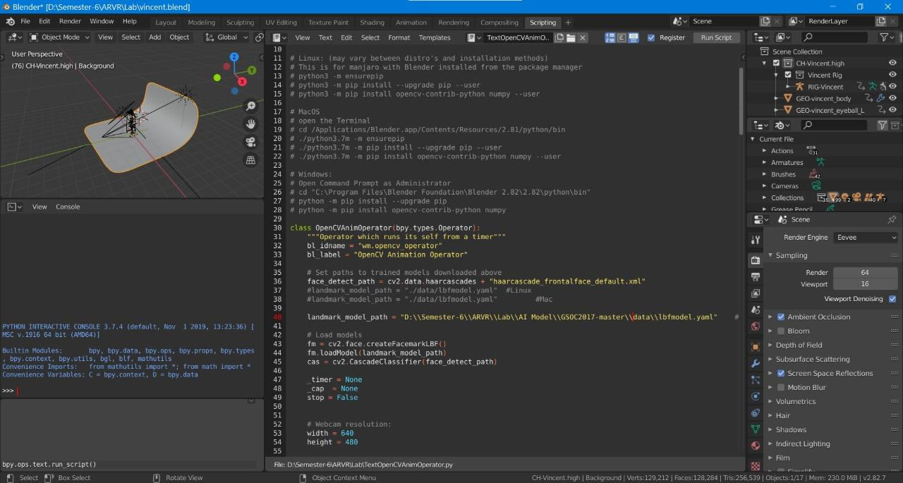

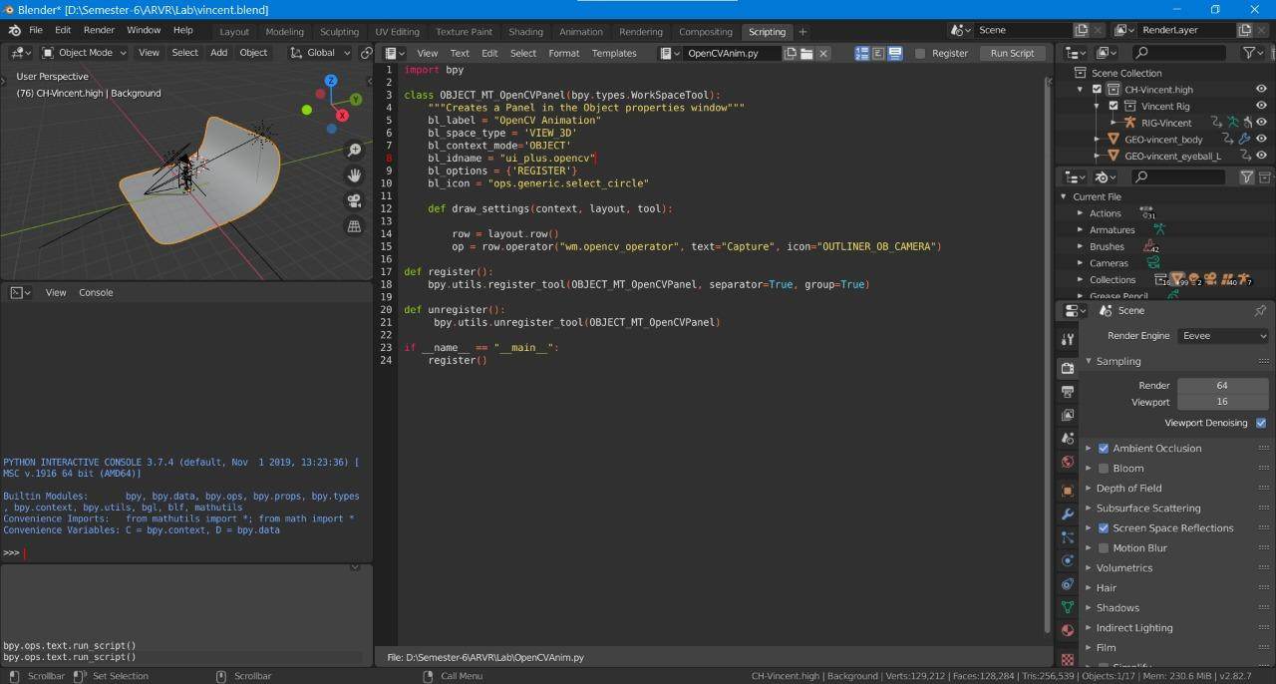

**Contribution:**

**1.Avinash - Working model.**

**2.Preethika- Working model.**

**3.Kishore - Helped us sort errors and glitches in the program**

**4.Parthib - Helped us sort errors and glitches in the program.**